# Problem 2 - Numbers

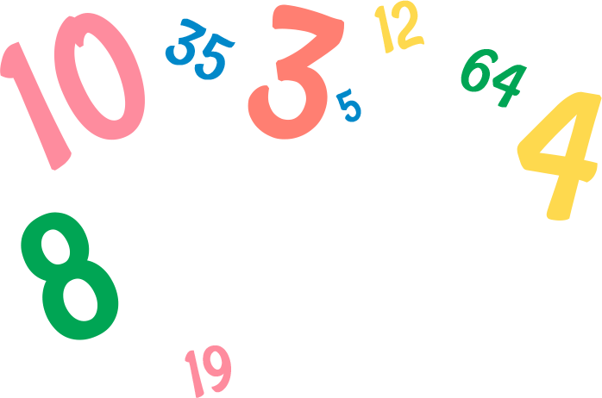

You are given **numbers** in **a sequence on a single line, separated by a space**. After that, you will receive **commands** that modify the sequence differently:

* **"Add {value}"** - you should **add** the given value to **the end** of the sequence.
* **"Remove {value}"** - you should **remove** the **first occurrence** of the given value if there is such.
* **"Replace {value} {replacement}"** - you should **replace** the **first occurrence** of the **given value** with the **replacement** if there is such occurrence.
* **"Collapse {value}"** you must **remove each number with a value less** than the given one.

When you receive the command **"Finish"**, you should **print the modified sequence** and end the program.

### Input / Constraints

* On the first line, you will receive a sequencewithnumbers, separated by spaces - integers in the range

**[-1000…1000].**

* On the following lines, you will receive commands until the **"Finish"** command is received.
* The commands will always be valid.

### Output

* Print a single line the array of numbers separated by a space, with the modified values.

### Examples

|  |  |
| --- | --- |
| **Input** | **Output** |
| 1 4 5 19  Add 1  Remove 4  Finish | 1 5 19 1 |
| 1 20 -1 10  Collapse 8  Finish | 20 10 |
| 5 9 70 -56 9 9  Replace 9 10  Remove 9  Finish | 5 10 70 -56 9 |

### JS Examples

The input will be provided as an array of strings.

|  |  |
| --- | --- |
| **Input** | **Output** |
| (["1 4 5 19",  "Add 1",  "Remove 4",  "Finish"]) | 1 5 19 1 |
| (["1 20 -1 10",  "Collapse 8",  "Finish"]) | 20 10 |
| (["5 9 70 -56 9 9",  "Replace 9 10",  "Remove 9",  "Finish"]) | 5 10 70 -56 9 |